ACTORS
The system has only one actor:
1. Player
Player is the actor who starts the system and controls the game flow including all features of the game.

IDENTIFICATION OF ACTORS
  - Actor can use the system
  - Actor can select menu
  - Actor can show game screen
  - Actor can go to standings menu
  - Actor can go to training menu
  - Actor can go to team menu
  - Actor can go to fixture menu
  - Actor can go to transfer menu
  - Actor can go to match menu

USE CASES
- Select Menu
- Show Game Screen
- Go to Standings Menu
- Go to Training Menu
- Go to Team Menu
- Go to Fixture Menu
- Go to Transfer Menu
- Go to Match Menu

- Select Menu
1.a) Unique Name: Select Menu
1.b) Participating Actor: Player
1.c) Entry Condition: Player must execute the game
1.d) Exit Condition: Player must make a menu choice
1.e) Flow Event:
- Player makes a menu choice
- The window belongs the choice is opened or the action is performed
1.f) Special requirements: None.

- Show Game Screen
2.a) Unique Name: Show game screen
2.b) Participating Actor: Player
2.c) Entry Condition: Start new game or load a saved game
2.d) Exit Condition: Make an in-game choice
2.e) Flow Event:
- Player makes an in-game choice
- The window belongs the choice is opened (e.g. Standings, Training Menu, Team Menu, Fixture Menu, Transfer Menu, Match Menu)
2.f) Special requirements: None.

- Go to Standings Menu
3.a) Unique Name: Go to Standings Menu
3.b) Participating Actor: Player
3.c) Entry Condition: Click “Standings” button on Game Screen
3.d) Exit Condition: Click “Return to Game Screen” button
3.e) Flow Event:
- Player clicks “Standings” button
- Team Standings is displayed to the Player by default
- Wrestler Standings (for each weight) can be displayed according to player choice
- Returns to Game Screen when the button is pressed.
3.f) Special requirements: None.

- Go to Training Menu
4.a) Unique Name: Go to training menu
4.b) Participating Actor: Player
4.c) Entry Condition: Click “Training” button on Game Screen
4.d) Exit Condition: Click “Return to Game Screen” button
4.e) Flow Event:
- Player clicks “Training” button
- Current training programs for each wrestler are fetched from database.
- Player decides a training program for each wrestler of his/her team.
- Wrestler attributes are updated according to previous trainings and works.
- Returns to Game Screen when the button is pressed.
4.f) Special requirements:
- Wrestler improvement frequency decreases due to his attributes' improvement.

- Go to Team Menu
5.a) Unique Name: Go to team menu
5.b) Participating Actor: Player
5.c) Entry Condition: Click “Team” button on Game Screen
5.d) Exit Condition: Click “Return to Game Screen” button
5.e) Flow Event:
- Player clicks “Team” button
- Current wrestler list and strategies for each wrestler are fetched from database.
- Player decides team squad.
- Player decides game strategies (e.g. aggression) for each wrestler.
- Returns to Game Screen when the button is pressed.
5.f) Special requirements:
- Player must select one and only wrestler for each weight. (5 wrestlers total)

- Go to Fixture Menu
6.a) Unique Name: Go to fixture menu
6.b) Participating Actor: Player
6.c) Entry Condition: Click “Fixture” button on Game Screen
6.d) Exit Condition: Click “Return to Game Screen” button
6.e) Flow Event:
- Player clicks “Fixture” button
- Fixture (match lists) is fetched from database.
- Returns to Game Screen when the button is pressed.
6.f) Special requirements: None.

- Go to Transfer Menu
7.a) Unique Name: Go to transfer menu
7.b) Participating Actor: Player
7.c) Entry Condition: Click “Transfer” button on Game Screen
7.d) Exit Condition: Click “Return to Game Screen” button
7.e) Flow Event:
- Player clicks “Transfer” button
- Wrestler list and prices, team budgets are fetched from database
- Player explores the transfer lists.
- Player make a deal with a wrestler for his/her team
- After the transfer takes place the updated budget is written to database.
- Returns to Game Screen when the button is pressed
7.f) Special requirements:
- Player's club must have enough budget to make the deal.

- Go to Match Menu
8.a) Unique Name: Go to match menu
8.b) Participating Actor: Player
8.c) Entry Condition: Click “Match” button on Game Screen
8.d) Exit Condition: Click “Return to Game Screen” button
8.e) Flow Event:
- Player clicks “Match” button
- The match program belongs the day, match commentary sentences are fecthed from database
- Match result is produced by system's simulation engine due to comparision of player attributes
- Produced match result is written to database
- Returns to Game Screen when the button is pressed
8.f) Special requirements: None.

- Start New Game
9.a) Unique Name: Start new game
9.b) Participating Actor: Player
9.c) Entry Condition: Click “Start New Game” button on Select Menu
9.d) Exit Condition: Start new game with default database datas
9.e) Flow Event:
- Player clicks “Start New Game” button
- A database is created for player.
- Default values for whole system is generated and written to new database
- Goes to Game Screen when the previous step is done
9.f) Special requirements: None.

- Load Saved Game
10.a) Unique Name: Load saved game
10.b) Participating Actor: Player
10.c) Entry Condition: Click “Load Game” button on Select Menu
10.d) Exit Condition: Start the game with saved database datas
10.e) Flow Event:
- Player clicks “Load Game” button
- Game datas are fetched from player's database
- Goes to Game Screen when the previous step is done
10.f) Special requirements: None.

- Choose Training Type
11.a) Unique Name: Choose training type
11.b) Participating Actor: Player
11.c) Entry Condition: Player goes to Training Menu
11.d) Exit Condition: Click “Return to Game Screen” button
11.e) Flow Event:
- Player goes to Training menu
- Player chooses a training type for wrestler's improvement
- The choice is written to the database
- Returns to Game Screen when the button is pressed
11.f) Special requirements: None

- Choose Wrestler to Train
12.a) Unique Name: Choose wrestler to train
12.b) Participating Actor: Player
12.c) Entry Condition: Player goes to Training Menu
12.d) Exit Condition: Click “Return to Game Screen” button
12.e) Flow Event:
- Player goes to Training menu
- Player chooses a wrestler to set the training menu for him
- The training type is applied for the wrestler
- Returns to Game Screen when the button is pressed
12.f) Special requirements: None.

- Choose Squad
13.a) Unique Name: Choose squad
13.b) Participating Actor: Player
13.c) Entry Condition: Player goes to Team Menu
13.d) Exit Condition: Click “Return to Game Screen” button
13.e) Flow Event:
- Player goes to Team menu
- Current squad is fetched from database
- Player decides 5 wrestler for his/her squad
- The choice is written to the database
- Returns to Game Screen when the button is pressed
13.f) Special requirements: None.

- Choose Strategy
14.a) Unique Name: Choose strategy
14.b) Participating Actor: Player
14.c) Entry Condition: Player goes to Team Menu
14.d) Exit Condition: Click “Return to Game Screen” button
14.e) Flow Event:
- Player goes to Team menu
- Current strategy is fetched from database
- Player sets match strategies for each wrestler
- The choice is written to the database
- Returns to Game Screen when the button is pressed
14.f) Special requirements: None.

- Transfer Wrestler
15.a) Unique Name: Transfer Wrestler
15.b) Participating Actor: Player
15.c) Entry Condition: Player goes to Transfer Menu
15.d) Exit Condition: Click “Return to Game Screen” button
15.e) Flow Event:
- Player goes to Transfer menu
- Wrestler list for each team is fetched from database
- Player transfers a wrestler to his/her team (if team budget is enough)
- Updated squad list is written to the database
- Returns to Game Screen when the button is pressed
15.f) Special requirements:
- Player's club must have enough budget to make the deal.

- Simulate the Match
16.a) Unique Name: Simulate the match
16.b) Participating Actor: Player
16.c) Entry Condition: Player goes to Match Menu
16.d) Exit Condition: Click “Return to Game Screen” button
16.e) Flow Event:
- Player goes to Match menu
- Match program of fixture is fetched from database
- Simulation engine generates match highlights, and a result of the match according to these highlights.
- Returns to Game Screen when the button is pressed
16.f) Special requirements:
- Match highlights and results are generated according to wrestler attributes.

REQUIREMENTS-TRACEABILITY MATRIX

Use Cases → | Select Menu | Show Game Screen | Go to Standings Menu | Go to Training Menu | Go to Team Menu | Go to Fixture Menu | Go to Transfer Menu | Go to Match Menu
Req.s ↓
Data Inputs To System | √ | √ |  | √ | √ |  | √
Process To Do At Each Screen | √ | √ | √ | √ | √ | √ | √ | √
Workflow By System |  |  | √ |  |  | √ |  | √
Description Of System Reports And Outputs |  |  |  |  |  |  |  | √
Control Of System Users | √
Database Reading & Writing | √ |  | √ | √ | √ | √ | √ | √

USE CASE DIAGRAM
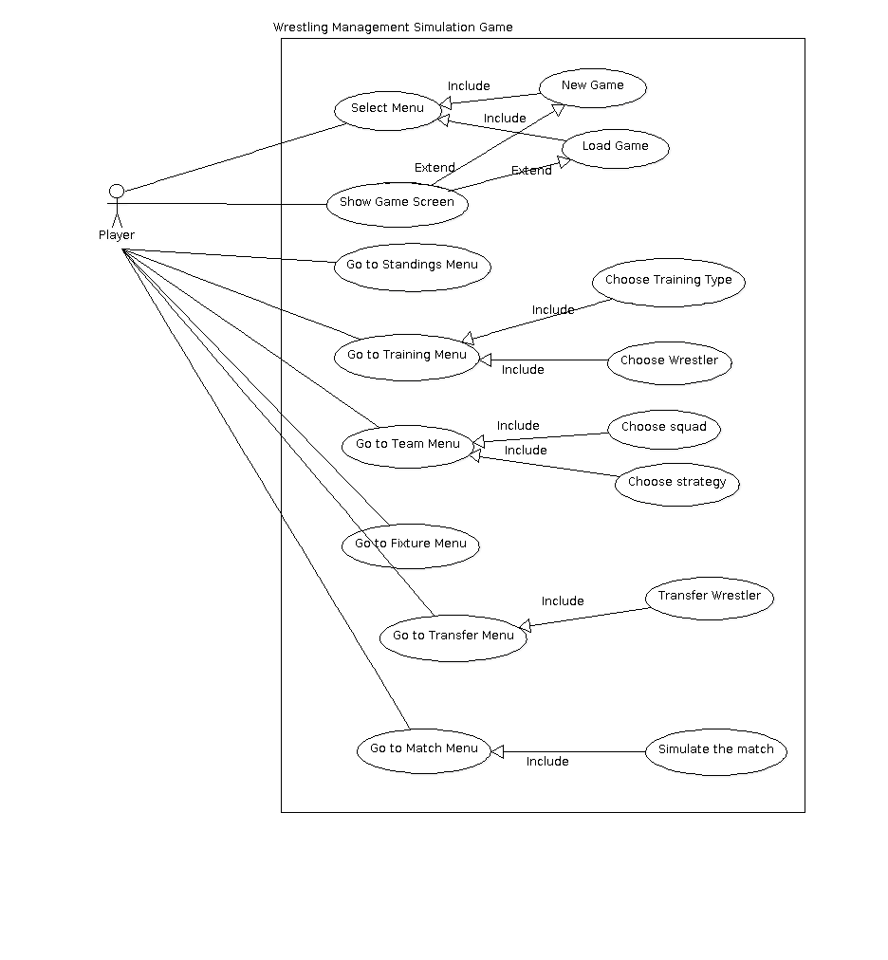
CLASS DIAGRAM

